초고속 V2X 통신기반
자율주행 서비스 기술 개발
[초고속 V2X 사이드링크 Open-Loop 전력제어 성능검증서]

2023. 12. 3

과제번호 | 2021-0-01140
과 제 명 | 초고속 V2X 통신기반 자율주행 서비스 기술 개발
등록번호 | IHU_MTRL-2023-5GV2X_Srvc_TR01
제·개정일자 | ‘23. 12. 3 (Ver. 1.0)



Table of Contents

- V2X Sidelink Open Loop Power Control 2
  - Open Loop Power Control in Sidelink Communications
  - Architecture of Sidelink OLPC
  - Framework of Sidelink OLPC
  - Proposed Sidelink Adaptive OLPC Algorithm
  - Simulation Scenario and Parameters Setting
  - Result Discussions
References 13

- Development of Sidelink Open Loop Power Control
  - Sidelink Open Loop Power Control
- Sidelink Open Loop Power Control is a power control technique used in wireless communication systems. This technology is primarily employed in scenarios where devices communicate directly with each other rather than through a base station.
- In such direct communication scenarios, Sidelink Open Loop Power Control helps devices autonomously adjust their transmission power without central scheduling. The term "open loop" indicates that in this process, devices adjust their power without direct feedback, as opposed to closed-loop control based on received signal quality feedback.
- Through open-loop power control, devices can autonomously adapt their transmission power based on predefined rules or guidelines to accommodate various communication conditions, such as distance and channel states. This helps improve communication reliability, reduce interference, and optimize system performance. Sidelink Open Loop Power Control is a technical means used in cellular communication systems to support direct communication between devices.
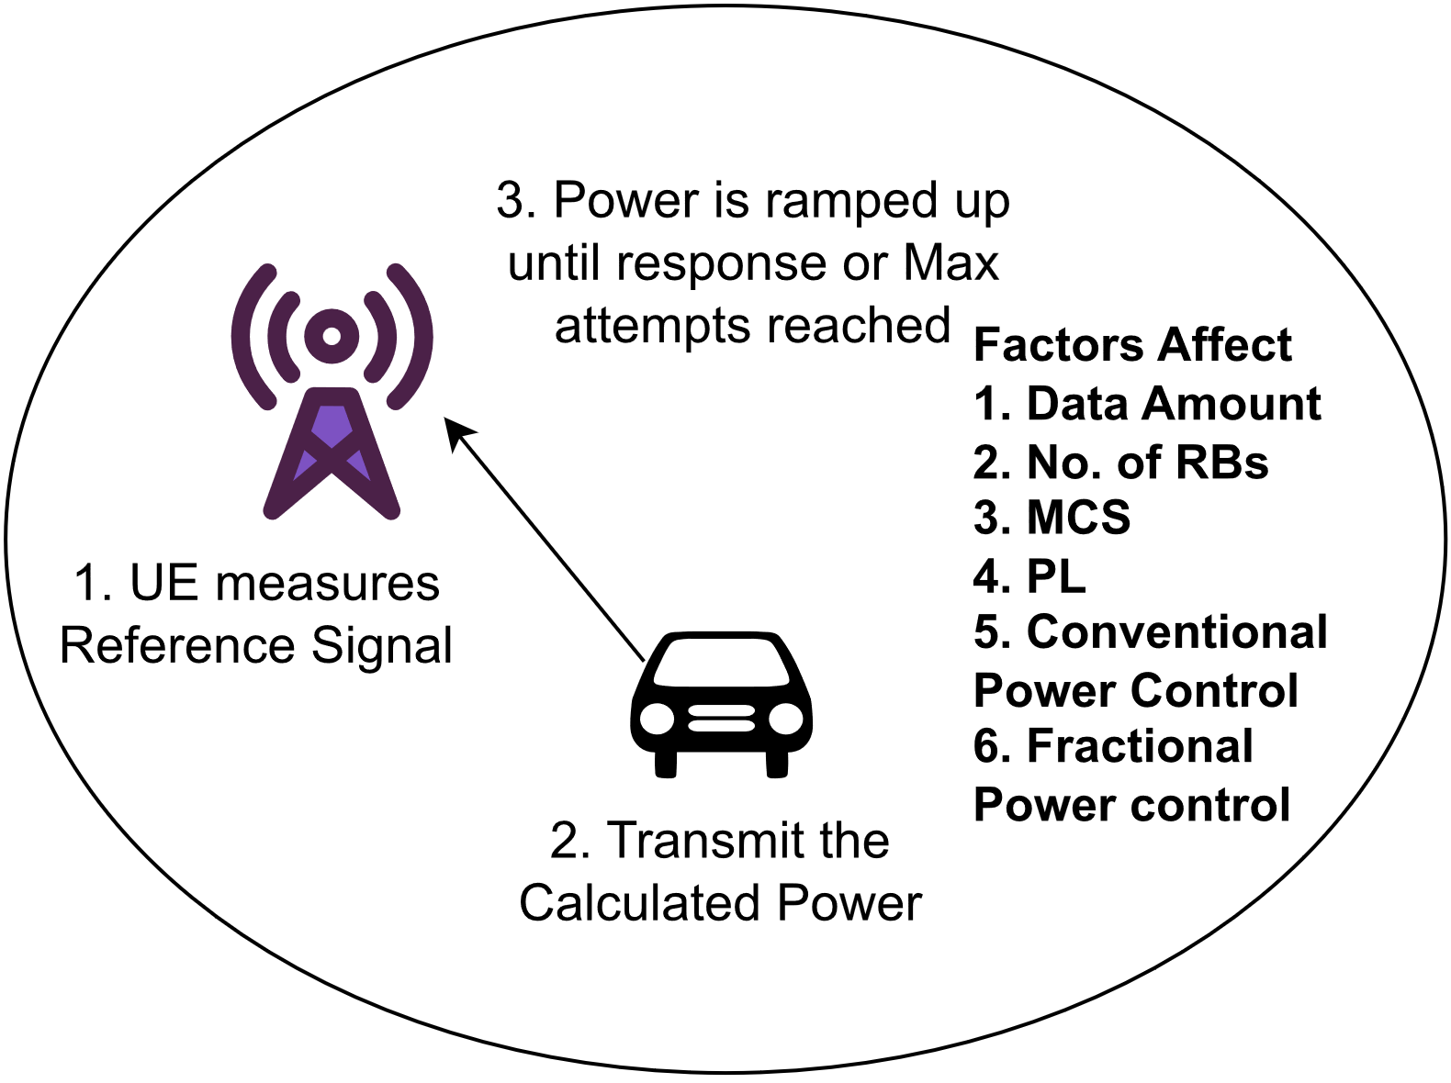
< Fig.1: Process of the OLPC and influencing factors >
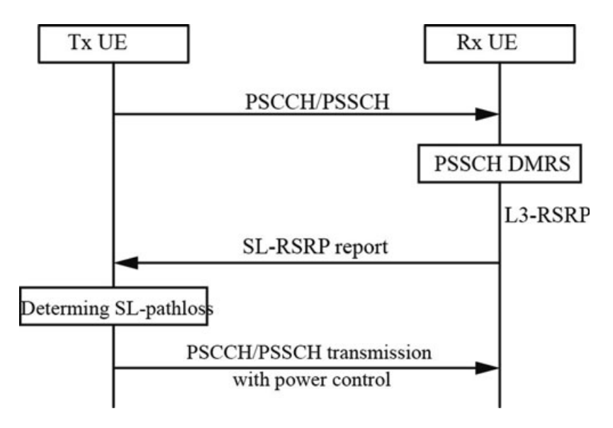
< Fig.2: Process of the OLPC General Algorithm>
- Power Control System
  - Open Loop Power Control (OLPC)
  - Closed Loop Power Control (CLPC)
- Overview of the key differences
- Feedback Mechanism
  - OLPC adjusts the transmission power of a device without relying on explicit feedback from the receiver. It typically relies on predefined rules or guidelines based on factors like distance, channel conditions, and other environmental parameters.
  - CLPC, on the other hand, uses feedback from the receiver to adjust the transmission power. The receiver provides information about the quality of the received signal, and the transmitter adjusts its power accordingly to maintain a desired signal quality.
- Autonomy
  - OLPC: It operates autonomously without direct feedback. The transmitter makes power adjustments based on predetermined rules, reducing the need for continuous communication with the receiver.
  - CLPC: It requires a continuous feedback loop between the transmitter and the receiver. The transmitter adjusts power in response to real-time feedback, making it a more dynamic and responsive system.
- Complexity
  - OLPC is simpler in terms of implementation as it doesn't require a feedback loop. It relies on predefined parameters to make power adjustments.
  - Implementing a closed-loop system involves more complexity due to the need for feedback mechanisms, real-time processing, and coordination between the transmitter and receiver.
- Use Cases
  - OLPC: Often used in scenarios where quick adjustments are needed based on general environmental conditions. It is commonly employed in sidelink communications and scenarios where V2V communication is involved.
  - CLPC: Commonly used in cellular networks where base stations and mobile devices continuously exchange feedback to optimize the signal quality and network performance.
- Since TPC command is no longer supported in Sidelink communication, there is only OLPC in SL.
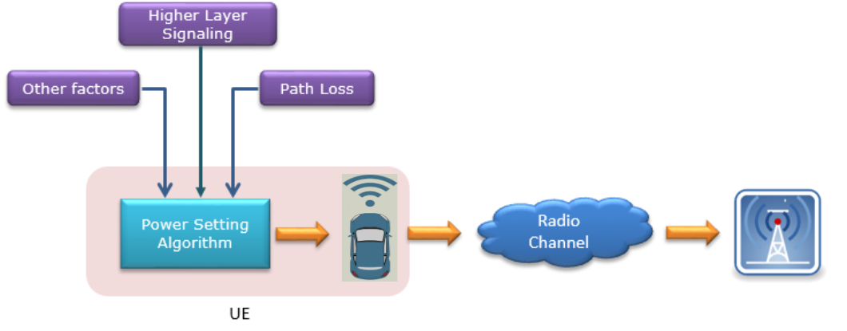
< Fig.3: OLPC Model >
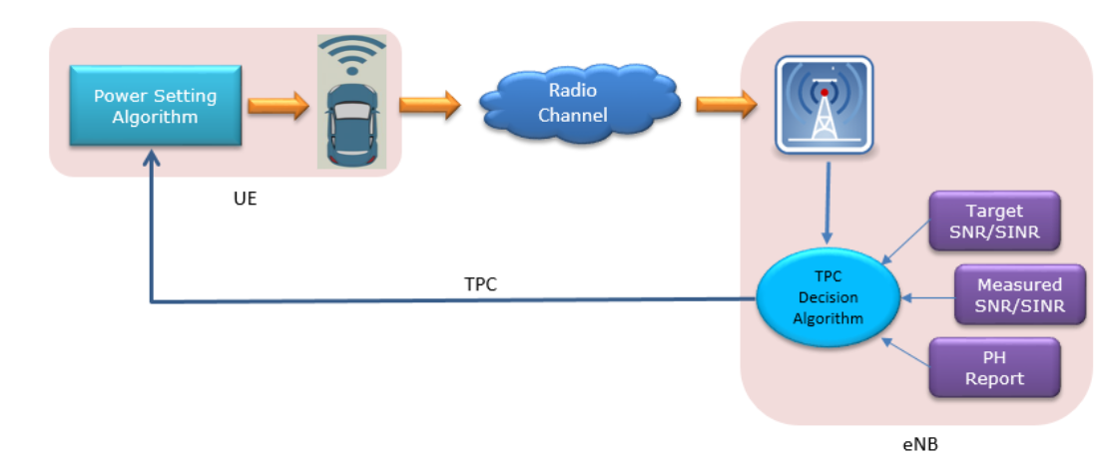
< Fig.4: CLPC Model >

  - Architecture of Sidelink OLPC
- User Equipment (UE): This refers to the individual devices or terminals participating in the sidelink communication.
- The Sidelink Communication Interface: There needs to be a dedicated communication interface that allows direct communication between UEs.
- Sidelink Open Loop Power Control Algorithm: This is the core algorithm that governs how UEs adjust their transmission power without explicit feedback from the receiver. It takes into account factors like distance, channel conditions, and predefined power control rules to autonomously adjust transmission power levels.
- Communication Resources: The architecture should define how communication resources, such as time slots or frequency bands, are allocated for sidelink communication. This allocation may be dynamic and depend on the current network conditions.
  - Framework of Sidelink OLPC
- Path Loss Estimation: The device estimates the path loss to its intended recipient based on factors like distance, environmental conditions, and signal attenuation.
- Power Setting: Based on the estimated path loss, the device sets its transmission power. The goal is to ensure reliable communication without causing unnecessary interference.
- Mobility Management: As devices move, their path loss estimations change, requiring adjustments in transmission power.
- Interference Management: In dense networks, managing interference among multiple V2V links is crucial. Power levels must be controlled to minimize interference with other sidelink communications and the cellular network.
  - Proposed Sidelink Adaptive OLPC Algorithm
- The AS-OLPC algorithm proposed in this study is designed to enhance the reliability and efficiency of V2V communication in 5G-NR-V2X networks. Unlike traditional OLPC techniques, AS-OLPC adapts dynamically to real-time channel conditions with considering interference, ensuring optimal power levels for sidelink communication without the need for direct receiver feedback.
- In the SINR Estimation and Adaptive Power Adjustment phase of the AS-OLPC algorithm, the system initiates real-time measurements to assess the quality of the communication channel. Upon the completion of each data transmission, the receiving device meticulously calculates the received signal strength and evaluates the interference levels present in the received signal. These parameters are crucial for computing the SINR, a pivotal metric that characterizes the channel conditions.
- The SINR value serves as a key indicator of the communication link's quality. If the computed SINR falls below a predetermined optimal threshold, suggesting suboptimal signal reception and potential communication instability, AS-OLPC initiates an adaptive power adjustment process. This process aims to enhance the SINR value by incrementally increasing the transmission power level.
- Adaptive Power Adjustment in AS-OLPC involves a controlled power increment, denoted as Δp, which represents the step size for power level adjustments. By judiciously increasing the transmission power, AS-OLPC seeks to improve the SINR, ensuring a more robust and reliable communication link. However, these power adjustments are conducted within predefined limits to prevent excessive interference with neighboring devices and to maintain energy efficiency.
- The adaptive nature of AS-OLPC's power adjustment mechanism allows the algorithm to respond dynamically to changing channel conditions. Continuous SINR monitoring and subsequent power adjustments enable AS-OLPC to optimize the communication link, maximizing the probability of successful packet reception. This meticulous balance between power adjustment, SINR enhancement, and interference mitigation forms the cornerstone of AS-OLPC's ability to adapt to real-time communication challenges in high-density vehicular environments.
- The vehicle density-based initialization phase of the SA-OLPC algorithm is essential for adapting communication strategies to the specific vehicular environment. In this phase, AS-OLPC assesses the density of vehicles within the communication range to determine the appropriate power level settings for the initial communication link establishment.
- The vehicle density-based initialization phase of the SA-OLPC algorithm is essential for adapting communication strategies to the specific vehicular environment. In this phase, AS-OLPC assesses the density of vehicles within the communication range to determine the appropriate power level settings for the initial communication link establishment.
- The moderate initial power level serves as a foundation for the subsequent adaptive power control strategies implemented by AS-OLPC. By starting with a moderate power setting, AS-OLPC minimizes the risk of signal overlap and collision with neighboring devices, fostering a stable communication foundation. This strategic initialization provides a robust starting point for AS-OLPC's adaptive algorithms to adjust the transmission power dynamically as the communication session progresses.
- AS-OLPC continuously monitors the vehicle density during the communication session. If the density surpasses the predefined threshold or fluctuates significantly due to changes in traffic patterns, AS-OLPC can dynamically adjust its power control strategies. This adaptive response ensures that AS-OLPC remains responsive to the evolving vehicular environment, maintaining efficient and reliable communication links in high-density scenarios.
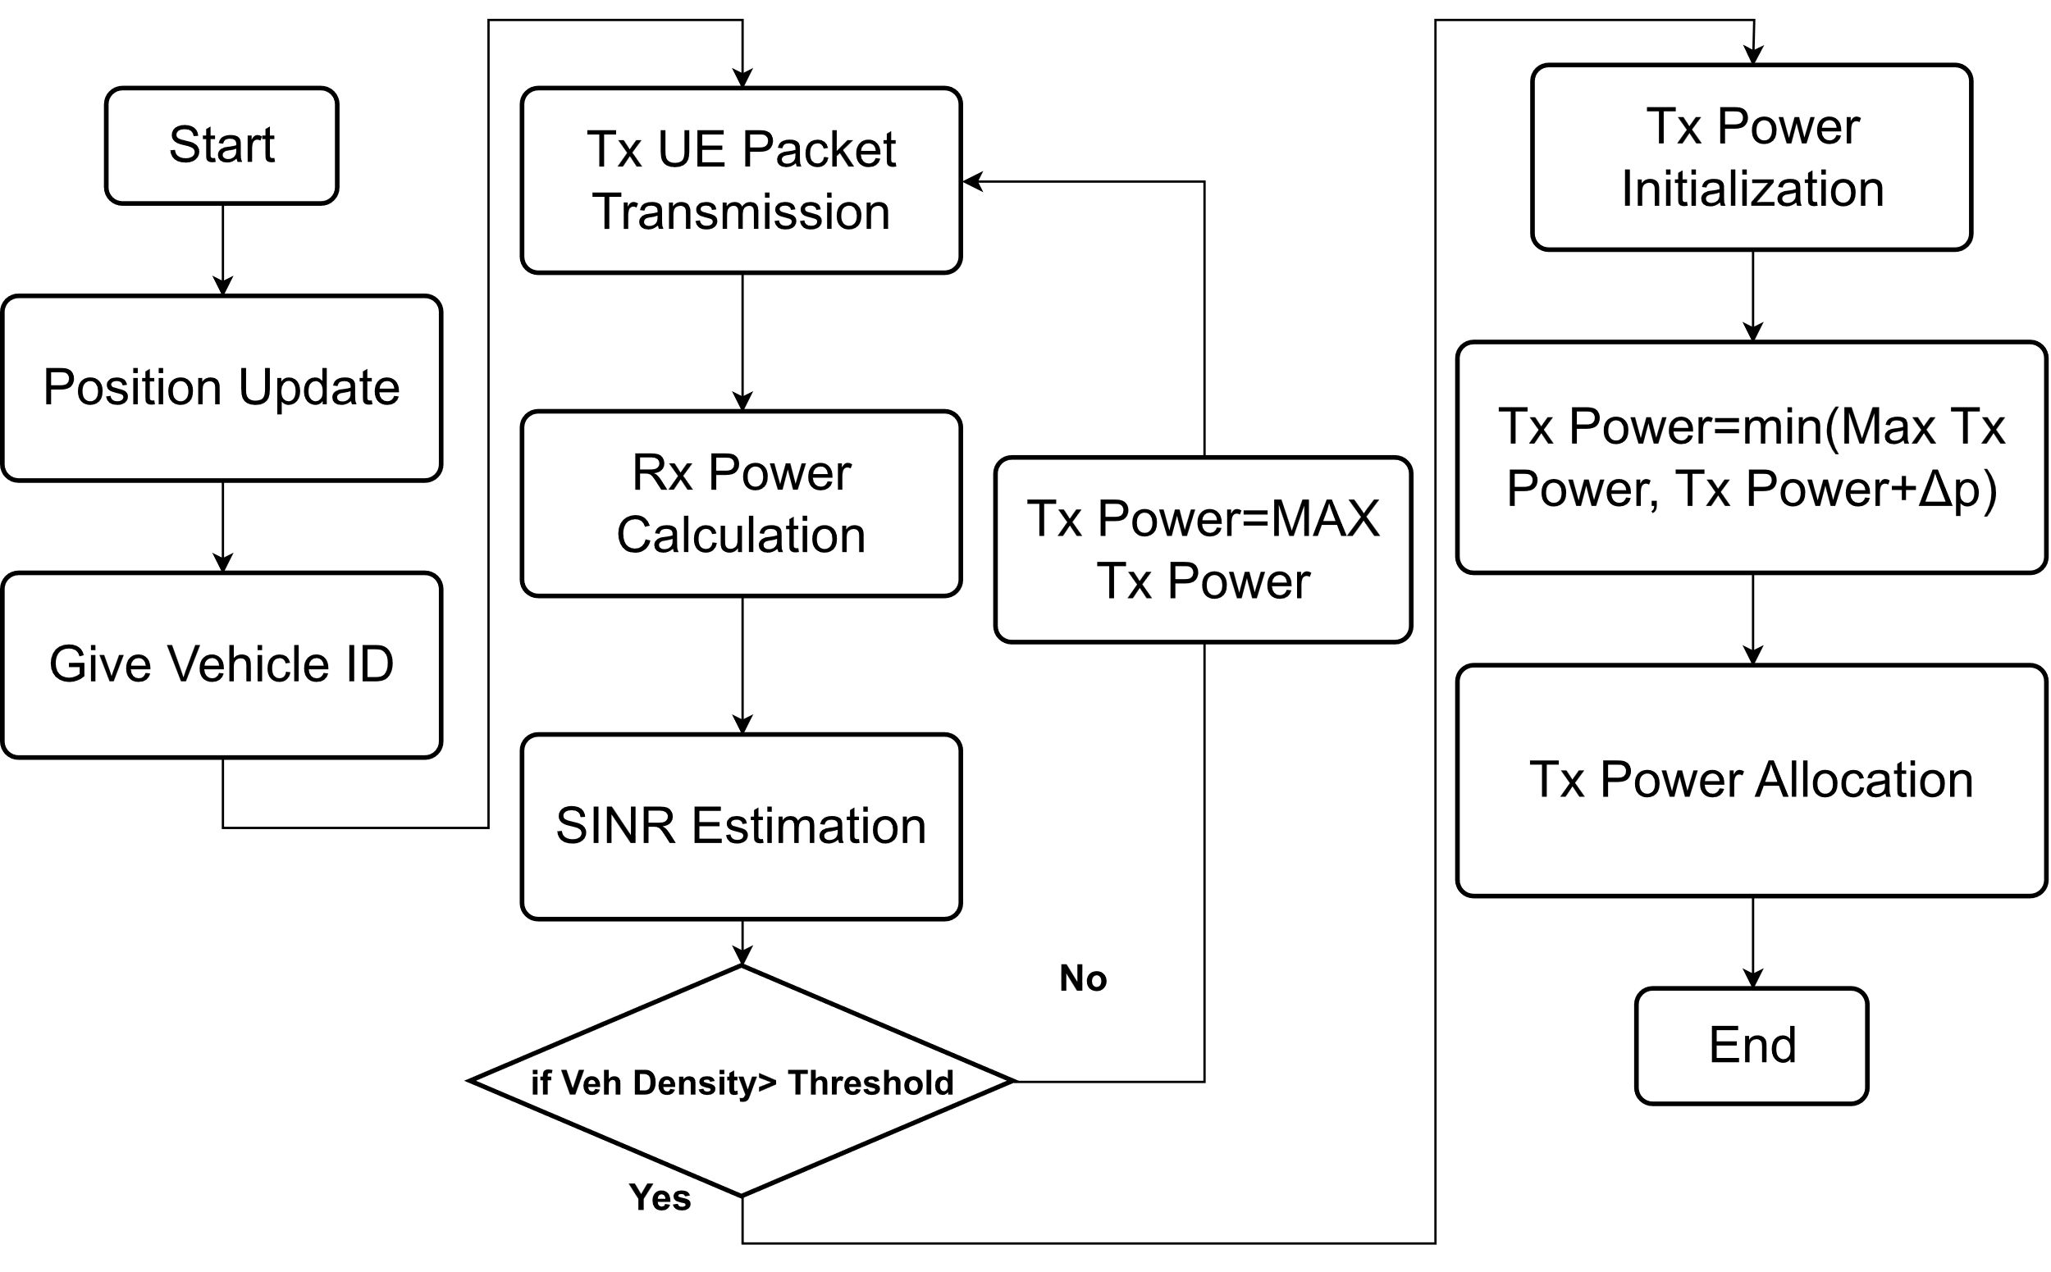
< Fig.5: CBR measurement >
- During the AS-OLPC processing, first upon packet transmission initiation, the algorithm initializes the transmission power level (Tx power) to a predefined starting value. After transmission, the algorithm calculates the received power at the intended receiver, considering the effects of path loss, shadowing, and potential interference. SA-OLPC leverages accurate SINR estimation techniques to evaluate the quality of the received signal. The SINR estimation is measured by:
${SINR}_{est}=\frac{{(P}_{txRB}·{AG}_{rx})/(PL·D_{ij}^{β})}{{(K}_{si}·P_{txRB}+P_{noise})+φ},$ (1)
- $P_{txRB}$ is the uplink transmit power per resource block, ${AG}_{rx}$ is the receiver antenna gain, PL is the path loss at 1 m. $D_{ij}^{β}$is the distance between the transmitter and receiver, β represents the loss exponent, $P_{noise}$ is the noise power level for each resource block, and $φ$ is calculated based on:
$φ=\sum_{\begin{aligned}k≠j \\ k∈K_{sub}\end{aligned}}{{(P}_{txRB}·{AG}_{rx})/(PL·D_{ij}^{β})},$ (2)
- The algorithm concludes the current transmission cycle, and the process is repeated for subsequent data packets. The iterative, adaptive nature of SA-OLPC ensures its responsiveness to the varying and dynamic conditions of vehicular communication environments. By integrating accurate SINR estimation and adaptive power adjustment, SA-OLPC aims to enhance the reliability, efficiency, and adaptability of Sidelink communication in 5G-NR-V2X networks.
< Algorithm 1: Adaptive Sidelink OLPC >
Algorithm 1 Adaptive Sidelink Open Loop Power Control
1: Parameters initialization: $P_{tx}=23dBm$
2: Vehicle position update
3: Vehicle number $V_{no}$ detection
4: SINR estimation:
$${SINR}_{est}=\frac{{(P}_{txRB}·{AG}_{rx})/(PL·D_{ij}^{β})}{{(K}_{si}·P_{txRB}+P_{noise})+\sum_{\begin{aligned}k≠j \\ k∈K_{sub}\end{aligned}}{{(P}_{txRB}·{AG}_{rx})/(PL·D_{ij}^{β})}}$$
5: Interference evaluation:
$${Inter}_{av}=\left(1-β\right)·{Inter}_{av}+β·{Inter}_{ainst}$$
6: if $Vehicle Densisy≥ ρ_{threshold}$:
7: then:
Tx power initialization: $P_{tx}(x)=10dBm$
8: if SINR＜${SINR}_{Target}$
$$P_{tx}\left(x+1\right)=\min\left(23,P_{tx}\left(x\right)+{SINR}_{est}+{Inter}_{av}\right)$$
9: else:
$$P_{tx}\left(x\right)=P_{max}$$
10: output
$$P_{tx}\left(x\right)$$

  - Simulation Scenario and Parameters Setting
    - Simulation Scenario
- The position of the vehicle obeys the Poisson distribution (parallel lines are randomly distributed).
- The calculation of Path Loss follows the 3GPP recommendation for vehicular communication, considering an antenna height of 1.5 m.
- The V2V sidelink channel is modeled based on the LOS, NLOS and NLOSv.
- 3GPP Highway scenario
  - The highway length is set to 4 km with three lanes in each direction, and the width of each lane is 4 m [30]. In this scenario, VUE moves with a predefined speed and when they reach the end of the road, they loop around and enter the opposite direction.
- 3GPP Urban scenario
  - 2 lanes with 3.5 meters width in each direction with road grid size 433 m*250 m, and simulation area size 1299 m* 750 m.
  - VUE moves with a predefined speed and when they reach the end of the road, they loop around and enter the opposite direction.
  - Within the intersection, a VUE follows different paths, proceeding straight, turning left, and turning right, with respective probabilities of 0.5, 0.25, and 0.25.
< Table.1: List of Parameters >
Parameter | Value
Road length for highway | 4000 m
Lane width | 3.5 m
Number of blocks for Urban | 9
Number of horizontal lanes  per block | 4
Speed | 120km/h, 60 km/h
Packet size | 350 bytes
Carrier frequency | 5.9 GHz
BW | 20 MHz
Channel model | CDL
Noise figure | 9 dB
MCS | 4/7
    - Result Discussions
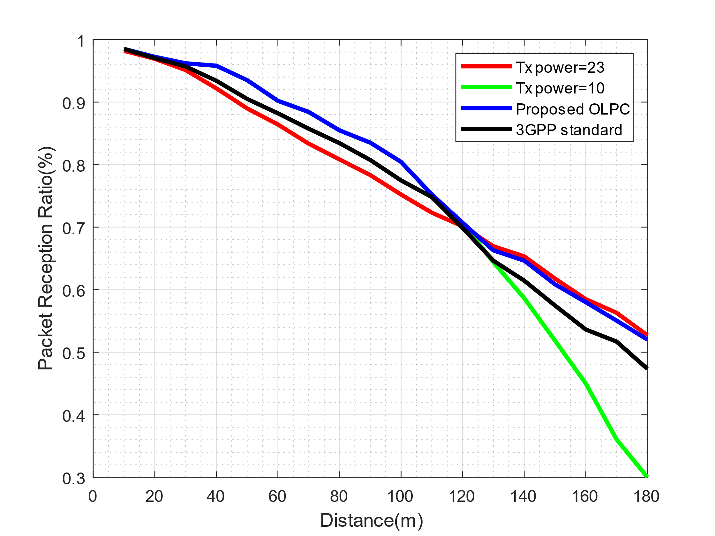
< Fig.6: Performance PER vs. Distance in Highway scenario with vehicle density = 200 >
- The PRR performance under fixed vehicle density = 200 conditions in a highway environment.
- As a comparison, the original OLPC scheme, different Tx power and the proposed AS-OLPC algorithm are compared, as shown in Figure 6.
- At close range, high Tx power results in worse channel reliability. Currently, higher Tx power causes higher interference levels.
- On the contrary, AS-OLPC is in the initialization Tx power state, that is, Tx power = 10 dBm, so the proposed OLPC performance curve overlaps with the Tx power = 10 dBm curve.
- In the case of long distance, because low Tx power cannot support effective packet transmission distance, PRR gradually decreases, and the gain of high Tx power on transmission distance is reflected.
- Currently, the proposed OLPC starts to gradually increase the Tx power until the Tx power is equal to the maximum value, so the PRR performance of the proposed OLPC gradually moves closer to Tx power = 23 dBm.
- And it can be seen that the performance of the proposed OLPC is always better than the predetermined power control algorithm.

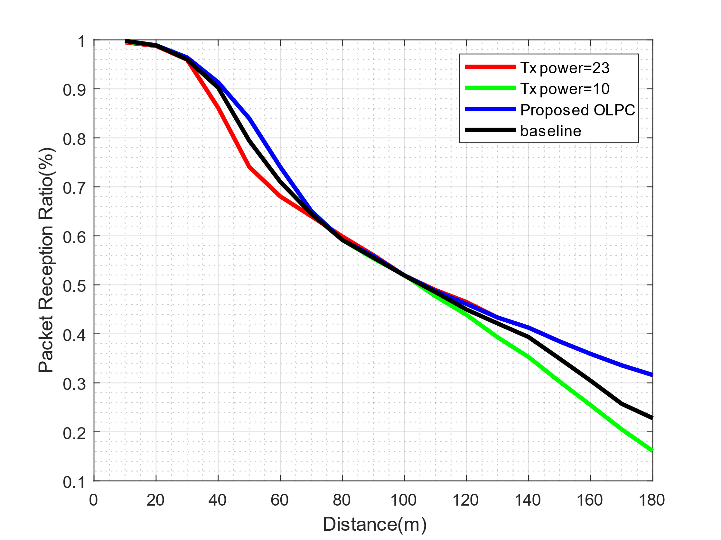
< Fig.7: Performance of AS-OLPC in medium Urban scenario.>
- Fig.7 shows the performance of the proposed OLPC in a medium congested Urban environment comparing different Tx powers.
- Similar to the test in the fixed vehicle density environment, the proposed OLPC performance curve coincides with the maximum Tx power performance curve at long distance, indicating that the proposed OLPC selects to run at maximum Tx power. At close distance, the PRR performance of proposed OLPC performance is same with Tx power = 10.
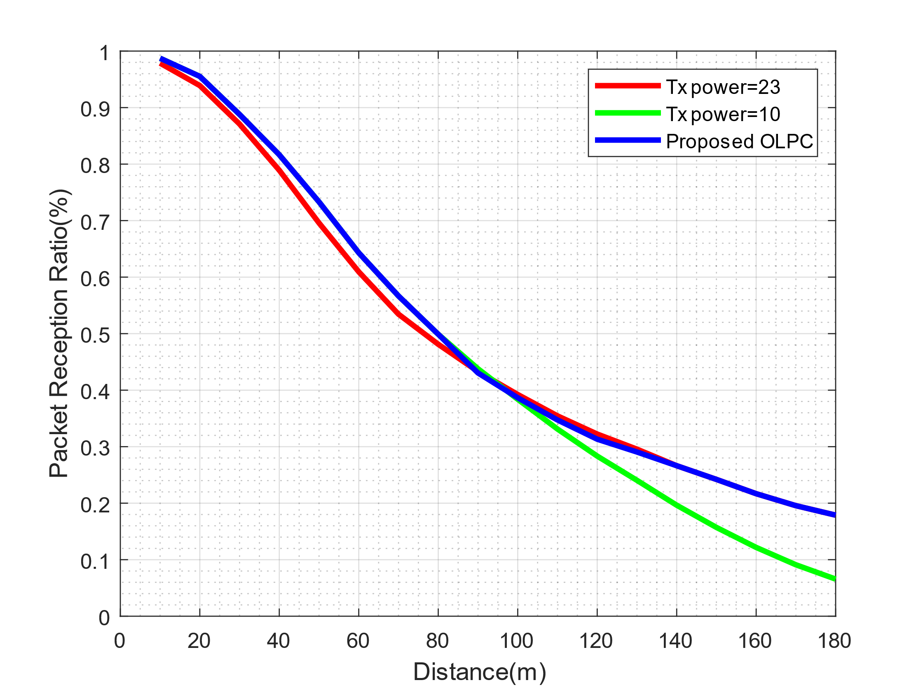
< Fig.8: Performance of AS-OLPC in congested Urban scenario >
- As shown in Figure 8, in a congested Urban environment, the proposed OLPC first uses lower Tx power to reduce the interference caused by Tx power to the system and increases Tx power when the distance increases to ensure sufficient transmission distance.
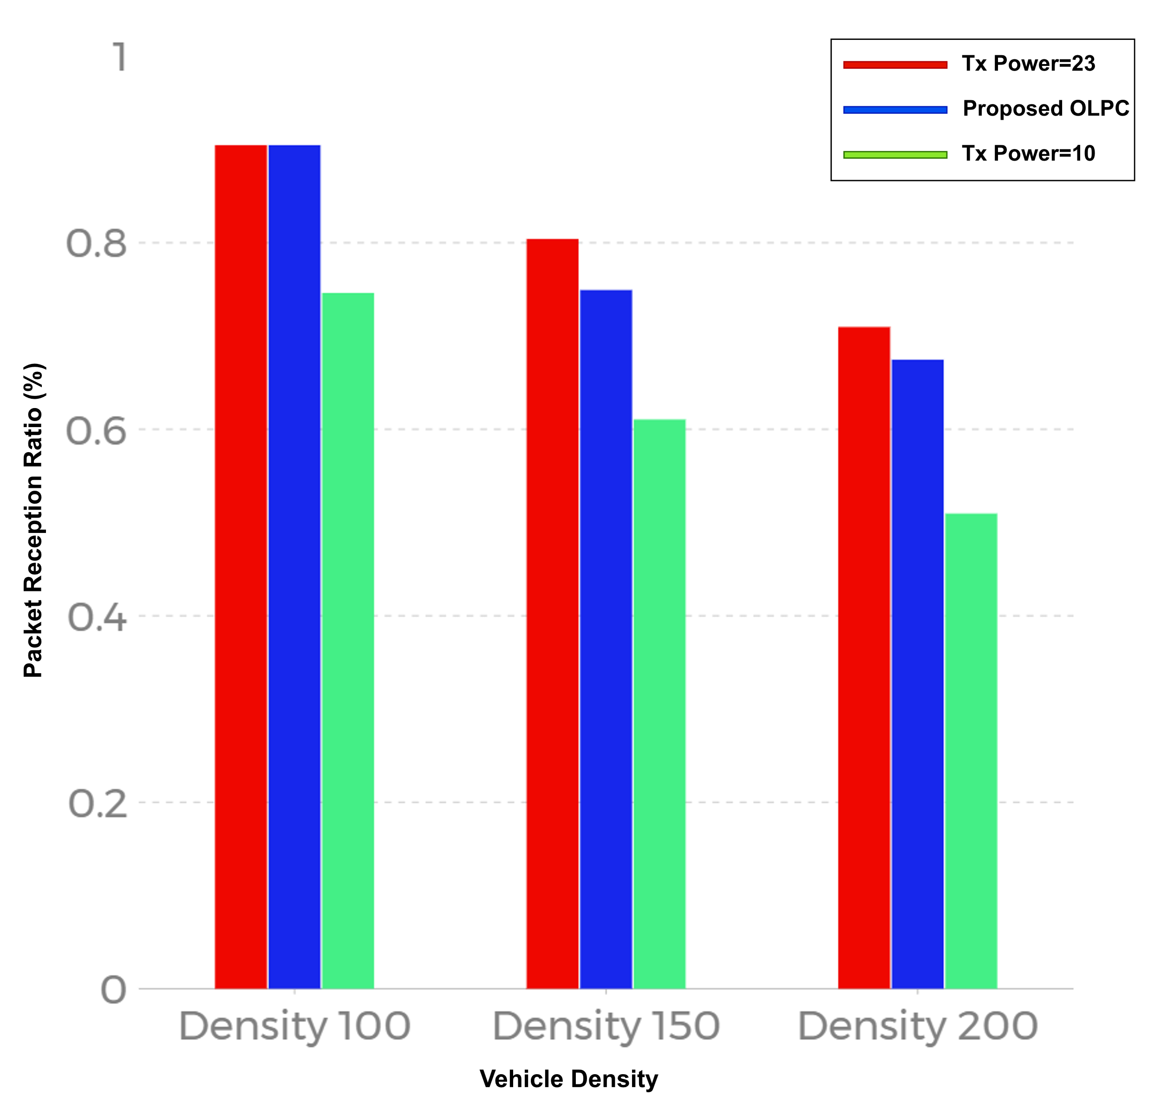
< Fig.9: Performance of AS-OLPC in various density scenarios >
- Under low vehicle density, the PRR performance of the proposed OLPC coincides with Tx power = 23 dBm.
- It can be judged that the vehicle density at this time has not reached AS-OLPC startup standard, the system always selects the maximum value of Tx power as the transmission indicator.
- As vehicle density increases, there is a decrease in PRR for all conditions. However, the proposed OLPC maintains a higher PRR than fixed Tx power = 10 dBm through its dynamic adjustment of transmission power and approaches the levels achieved under condition of maximum transmission power.

References
[1] A. Bazzi, A. O. Berthet, C. Campolo, B. M. Masini, A. Molinaro and A. Zanella, "On the Design of Sidelink for Cellular V2X: A Literature Review and Outlook for Future," in IEEE Access, vol. 9, pp. 97953-97980, 2021, doi: 10.1109/ACCESS.2021.3094161.
[2] S. Chen, J. Hu, Y. Shi, L. Zhao and W. Li, "A Vision of C-V2X: Technologies, Field Testing, and Challenges With Chinese Development," in IEEE Internet of Things Journal, vol. 7, no. 5, pp. 3872-3881, May 2020, doi: 10.1109/JIOT.2020.2974823.
[3] A. Bazzi, G. Cecchini, A. Zanella and B. M. Masini, "Study of the Impact of PHY and MAC Parameters in 3GPP C-V2V Mode 4," in IEEE Access, vol. 6, pp. 71685-71698, 2018, doi: 10.1109/ACCESS.2018.2883401.
[4] 3GPP, “TS 38.101-4 NR; User Equipment (UE) radio transmission and reception; Part 4: Performance requirements (version 17.4.0 Release 17) “3GPP, Tech. Spec., April 2022.
[5] Study on Evaluation Methodology of New Vehicle-to-Everything (V2X) Use Cases for LTE and NR, document TR 37.885, version 15.3.0, 3GPP, Jun. 2019.
[6] F. Goudarzi and H. Asgari, "Non-Cooperative Beacon Power Control for VANETs," in IEEE Transactions on Intelligent Transportation Systems, vol. 20, no. 2, pp. 777-782, Feb. 2019, doi: 10.1109/TITS.2018.2813258.
[7] M. Saifuddin, M. Zaman, B. Toghi, Y. P. Fallah and J. Rao, "Performance Analysis of Cellular-V2X with Adaptive & Selective Power Control," 2020 IEEE 3rd Connected and Automated Vehicles Symposium (CAVS), Victoria, BC, Canada, 2020, pp. 1-7, doi: 10.1109/CAVS51000.2020.9334605.
[8] V. Todisco, S. Bartoletti, C. Campolo, A. Molinaro, A. O. Berthet and A. Bazzi, "Performance Analysis of Sidelink 5G-V2X Mode 2 Through an Open-Source Simulator," in IEEE Access, vol. 9, pp. 145648-145661, 2021, doi: 10.1109/ACCESS.2021.3121151.
[9] S. Bartoletti, B. M. Masini, V. Martinez, I. Sarris and A. Bazzi, "Impact of the Generation Interval on the Performance of Sidelink C-V2X Autonomous Mode," in IEEE Access, vol. 9, pp. 35121-35135, 2021, doi: 10.1109/ACCESS.2021.3061913.

